Cosmic Junk

Abstract

Space junk has accumulated since the age of space exploration, littering millions of artificial space debris into the unknown daily. Produced by satellite collisions, failures, rocket launches, and accidental and deliberate explosions, action to combat the growing artificial debris in space has been analyzed by scientists from various perspectives – starting from the age of space exploration, outlining the cause and impact of space debris, tracking and classifying natural and artificial space debris, and effective solutions to deal with the growing amount of objects in space. These scientific studies quintessentially provide the scope of negative externalities and technologies behind space debris and its effects on the environment, future scientific discoveries, and humanity.

Introduction

Hearing the news of another rocket launch or SpaceX deploying their next-generation GPS satellite, have you ever wondered where it all goes? Space is vast, but is it just me who once thought it would be fascinatingly convenient if all of the non-functioning space junk gets sucked by a giant black hole? To comprehend accurately how space junk is removed, a joint effort to reduce the creation of new debris should be collaboratively addressed by following outlined guidelines with thorough procedures under potential collision circumstances.

History of Space Junk

The concept of launching artificially created objects into space first began on October 4, 1957: with the launch of Sputnik – a pioneer of artificial satellites to orbit Earth [1]. During this period of the Cold War, political tensions between two global superpowers – the United States and the Soviet Union – competed to develop advanced military technologies and weapons. The launch of Sputnik, with the ability to orbit Earth every 96 minutes, opened opportunities for greater technological benchmarks such as the Sputnik 2 and Explorer [1]; this also initiated the rapid accumulation of space debris. Additional historical evidence suggests that the first man-made ejecta that projected to space was a cap from the Pascal B test in August 1957 [2]. Yet, this is just speculation. Following the launch of Sputnik instigating the space race, the accumulation of space debris created from satellite collisions, failures, rocket launches, and accidental and deliberate explosions, space debris dump millions of microscopic fragments that add junk to the oceans, resulting in negative externalities in terms of environment, future scientific discoveries, and health risks [3].

Impact of Space Debris

First off, what is space debris? Space debris has multiple names, such as artificial debris or space junk, and refers to man-created objects that orbit the Earth that are no longer in use [3]. Orbital debris as a whole defines all clutter that is typically in low Earth orbit which interferes with satellites [3]. We can split space debris into two broad categories: natural debris and artificial (man-made) debris [4]. Natural debris such as meteoroids orbit the sun, and artificial debris such as “nonfunctional spacecraft, abandoned launch vehicle stages, mission-related debris, and fragmentation debris” orbit the Earth [4].

Despite the fact that there are 107000 tonnes of space debris that orbit Earth and often enter the atmosphere, these particles typically burn up without actually crashing into the land [6]. However, the friction causing this debris to melt releases “metals and polymers” that deplete the ozone layer as its burning reaction produces nitric oxide [9]. While on a larger scale, the occurrences are negligible to the ozone layer or other environmental impacts, in the long run, these small pieces can add up to something greater such as climate change [9]. Apart from environmental concerns, a greater risk is the increased probability of collisions. Researchers report that space debris 20 centimeters - 25.4 centimeters is projected to multiply by a factor of 3.2, and space debris smaller than 10 centimeters is expected to multiply 13 - 20 times [10]. These statistics illustrate the considerable impact of excess space debris on satellites, which can not only be costly but harmful to those working on spacecraft.

Classifying Space Debris

The diagram below illustrates the classification of orbital space debris according to whether it is a consequence of man-made space technology or a piece created from collision, explosion, or a similar circumstance [5]. To further explain the function of the diagram, natural debris includes those that originate inside or outside the solar system. Substances that are extrasolar include dust and larger bodies, whereas those that exist in the solar system are either comets or asteroids which are further broken down as meteoroids and interplanetary dust [5]. Artificial debris is divided into two categories as shown in **Figure 1**, depicting the byproducts of human creation that are no longer in function and fragments resulting from collisions or explosions.

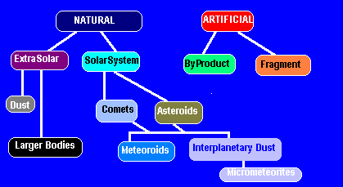

**Fig. 1 Space Debris Classification Scheme.** The diagram depicts the natural and artificial classification of space debris, breaking it down into smaller pieces [5].

In general, artificial debris is man-made, typically resulting from a collision that creates a fragment or a byproduct. While further research on space is required to precisely define space debris and its impacts, comets and asteroids are classified as natural debris as it orbits the sun [5]. Comets originate from the Oort cloud region and can be considered either short and long period bodies [5]. Occasionally, they are thrown into irregular orbits which interfere with the inner solar system [5]. This can also cause comets to be captured into short-period orbits by a nearby planet – typically Jupiter [5].

Asteroids are denser than comets (approximately 3500 ${kg/m}^{3}$) [5]; they are found in orbits in the main Asteroid Belt – located between Mars and Jupiter – and are theorized to be scattered throughout the solar system [5]. It is uncertain whether these fragments are a result of two larger planets colliding together or created from the original formation of the solar system [5]. Meteoroids and interplanetary dust, a branch under comets and asteroids as indicated on the diagram earlier, typically burn up in the Earth’s atmosphere or enter as a minuscule particles [5].

Space debris is also classified by its size to compare how many small, medium, and large particles are in Earth’s orbit. Those that are tracked by the Space Surveillance Network are reported as follows [6]:

* Space debris or objects greater than 10 centimeters in diameter – 36500
* Space debris or objects 1 centimeter to 10 centimeters in diameter – 1000000
* Space debris or objects 1 millimeter to 1 centimeter in diameter – 130 million

It is important to note that these ranges and numbers are as of December 2022 and do not include the smaller particles that are not tracked by the sensors due to technological limitations.

Tracking Space Debris

As of December 2022, the Space Surveillance Network reported over 130 million pieces of space debris that is greater than 1 millimeter to 1 centimeter in diameter [6]; 107000 tonnes of space mass in Earth’s orbit [6]; 36500 space debris larger than 10 centimeters in diameter [6]. This number does include the smaller particles that are too small in size to be sensed. Facilities and networks such as the Space Surveillance Network, NASA, DoD, Long Duration Exposure Facility, and other domestic and international establishments are responsible for tracking space debris to prevent dangerous collisions [3]. This is crucial because space junk moves up to 18000 miles per hour, which causes detrimental but also costly damage on active and inactive satellites [3]. Because such facilities are able to keep the radar of numerous space debris, crews on spacecraft are able to avoid such collisions by changing their pathway or preparing with proper equipment such as thick, protective spacesuits [3].

Because there are more than 36500 space debris larger than 10 centimeters in diameter orbiting Earth, even a small portion of this debris can cause costly and fatal damages as they travel at speeds up to 17500 miles per hour [4]. Examples such as the French satellite in 1996 that collided and exploded with a French rocket, China’s 2007 anti-satellite test to demolish an inactive weather satellite with the use of a missile, the collision of an inactive Russian spacecraft with an active United States commercial spacecraft, which all each added over 2000 larger pieces of debris and millions of tiny untrackable fragments, epitomizes how unintentional or deliberate collisions are not entirely optimal solutions to combat the growingly crowded space [4]. **Figure 2** shows various categories of potential debris ranging from varying payloads – aircraft cargo – rockets, and unidentified materials [7].

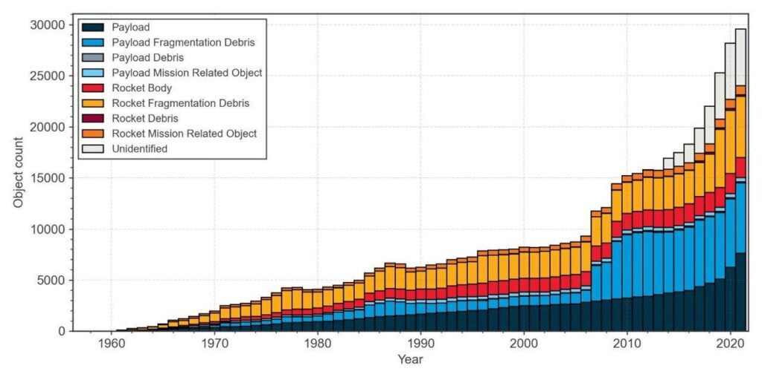

**Fig. 2 Tracking of Space Objects per Year.** This graph illustrates the increasing trend of the year-to-object count of debris in various categories [7].

According to **Figure 2**, the first known and tracked accident occurred in 2009 [7]; American telecommunications satellite Iridium 33 collided with Russian satellite Cosmos 2251, causing 3000 additional space debris to enter Earth’s orbit [7]. Scientists claim that collisions and accidents such as these will create an effect known as the Kessler syndrome: a situation where densities of objects culminate enough to cause a cascade – increasing the chances of another collision [7,8].

The Space Surveillance Network, operated by the United States Air Force, utilizes sensors to follow space debris greater than 10 centimeters in diameter [8]. These sensors are located across the world and typically look up to the sky at a lower point [8]. They are located in the following regions (as shown on the map below) and work to track, detect, image radar, and acquire necessary data to avoid collisions [8]. The grounded telescopes take optimal measurements [8]; the Optical Measurement Center (OMC) utilizes “a broadband light source, rather than a laser, and a photometric detector to calculate a spacecraft material’s photometric response through BRDF measurements” [8]. However, challenges in monitoring objects with imaging still persist due to poor illumination, high speed, and the small size of the debris [8].

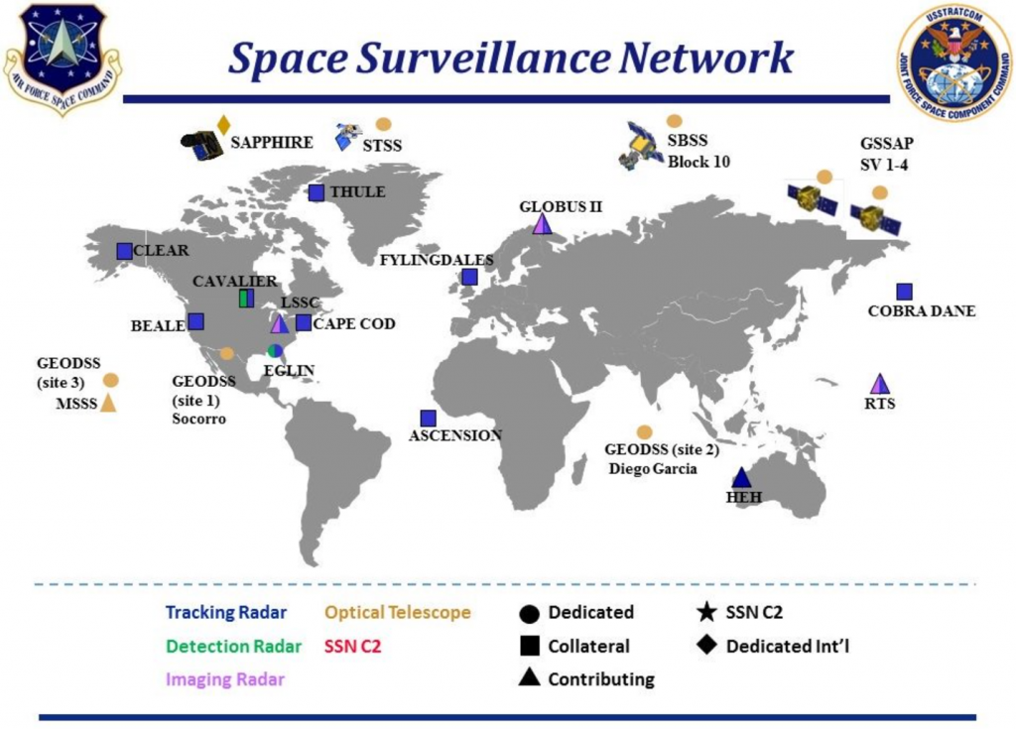

Fig. 3 Space Surveillance Network

Effective Solutions: Active or Passive

As of now, there are two space debris removal methods: active and passive. Removing space debris can open many opportunities for future scientific research, and room for new satellites, and minimize further collisions. Solutions include destroying particles to a minuscule size that does not harm contact [7]. Active debris removal requires energy from the spacecraft [7]. This includes capturing and tugging a spacecraft with another spacecraft, recycling, maintaining its own propulsion system out of Earth’s orbit, or “remote energy impact (laser or ion flow)” [7]. Passive debris removal does not require energy from the spacecraft [7]. This method focuses on decelerating and redirecting using an electrodynamic cable system that confines the particles, a solar sail, or an aerodynamic balloon that brakes the space debris [7].

Fortunately, there are few promising space debris removal projects. For example, RemoveDebris is a satellite designed to clean pieces that weigh up to 2 tons and are 2 meters in diameter [7]. The satellite contains a harpoon and net mechanism that pierces and captures space debris, and by 2019 February, it was successfully captured at a rate of 20 meters per second [7]. Another noteworthy project is ClearSpace-1. Collaborated by the European Space Agency and the Swiss industry, the mission of ClearSpace-1 is to “capture and deorbit”, launched by a Vega rocket [7]. This device gradually gains its assigned orbit by utilizing sensors and cameras to adjust its trajectory [7]. It’s quite simple: a satellite-sized Vespa is launched from the rocket itself and uses its robotic arms to secure the target, ultimately burning up together into the atmosphere [7]. Another example is the Space Tug project developed by Edinburg [7]. It is designed to tug and launch inactive satellites out of orbit or relocate them into a “disposal orbit” [7]; it is also designed to correct active satellites, launch cargo into lunar orbit, and refuel [7]. While there are several other upcoming and promising projects, it is important to note that most of these are either in their testing or preliminary phase. Thus, it is important that the globe as a whole makes an effort to reduce the creation of additional space debris until a definitive solution is found.

Conclusion

Concerns of space becoming one crowded junkyard is definitely a valid issue. The goal should be to focus on reducing the launching of additional space debris and increasing space debris-removing devices [4]. Potential solutions are using active or passive methods to quintessentially reduce the size and impact of space junk or to physically deorbit these objects. We should focus on implementing and developing passive methods as it is cost-effective (with no additional fuel costs). Because space debris enters our atmosphere – thankfully burning up and not impacting human populations directly – and pollutes our atmosphere with compositional chemicals that negatively affect our ozone, we should step up and pick up our space trash.

References

[1] B. Dunbar, “What is orbital debris?,” *NASA*, 01-Jun-2015. [Online]. Available: https://www.nasa.gov/audience/forstudents/5-8/features/nasa-knows/what-is-orbital-debris-58.html.

[2] C. Luke, “What is space junk and how does it affect the environment?,” *Earth.Org*, 06-Sep-2021. [Online]. Available: https://earth.org/space-junk-what-is-it-what-can-we-do-about-it/.

[3] E. Thorpe, “Space debris removal: Importance, today's methods & innovative spacecrafts,” *Orbital Today*, 12-Nov-2022. [Online]. Available: https://orbitaltoday.com/2022/03/30/space-debris-removal-importance-todays-methods-innovative-spacecrafts/.

[4] “Guide to Space Debris,” *Asa guide to space debris*, 2007. [Online]. Available: http://www.spaceacademy.net.au/watch/debris/debris.htm.

[5] “The history of space exploration,” *Education*. [Online]. Available: https://education.nationalgeographic.org/resource/history-space-exploration/.

[6] I. Thomson, “Did speeding American manhole cover beat Sputnik into space? top boffin speaks to El Reg,” *The Register® - Biting the hand that feeds IT*, 07-Jul-2021. [Online]. Available: https://www.theregister.com/2015/07/16/america_soviets_space_race/.

[7] K. K. Whitt, “Kessler syndrome of colliding satellites could make low-Earth orbit unusable,” *EarthSky*, 15-Nov-2021. [Online]. Available: https://earthsky.org/human-world/kessler-syndrome-colliding-satellites/#:~:text=Kessler%20syndrome:%20A%20scenario%20in,the%20likelihood%20of%20further%20collisions.

[8] M. Garcia, “Space debris and human spacecraft,” *NASA*, 14-Apr-2015. [Online]. Available: https://www.nasa.gov/mission_pages/station/news/orbital_debris.html.

[9] P. Editorial, “Tracking space junk to preserve the future of spaceflight,” *Possibility*, 28-Jun-2022. [Online]. Available: https://possibility.teledyneimaging.com/tracking-space-junk-to-preserve-the-future-of-spaceflight/#:~:text=The%20Space%20Surveillance%20Network%20is,also%20includes%20space%2Dbased%20satellites.

[10] “Space debris by the numbers,” *ESA*, 2022. [Online]. Available: https://www.esa.int/Space_Safety/Space_Debris/Space_debris_by_the_numbers.